Docker Task-2
- Create a tomcat container on 8080 and deploy sample application in tomcat.
  - Pull Tomcat Image
docker pull tomcat
  - Run Tomcat Container on Port 8080
docker run -d --name tomcat-8080 -p 8080:8080 tomcat
  - Verify Container Running
docker ps
Open browser: http:// 13.51.207.163: 8080
You should see Tomcat default page
  - Get Sample WAR File
You can download a sample WAR (example app):
wget hps://tomcat.apache.org/omcat-7.0-doc/appdev/sample/saple.war
Step 5: Deploy WAR into Tomcat Container
docker cp sample.war tomcat-8080:/usrlocal/tomcat/webapps/
  - Access Your Application
After few seconds, open:
http:// 13.51.207.163:8080/sample
Your application will be running

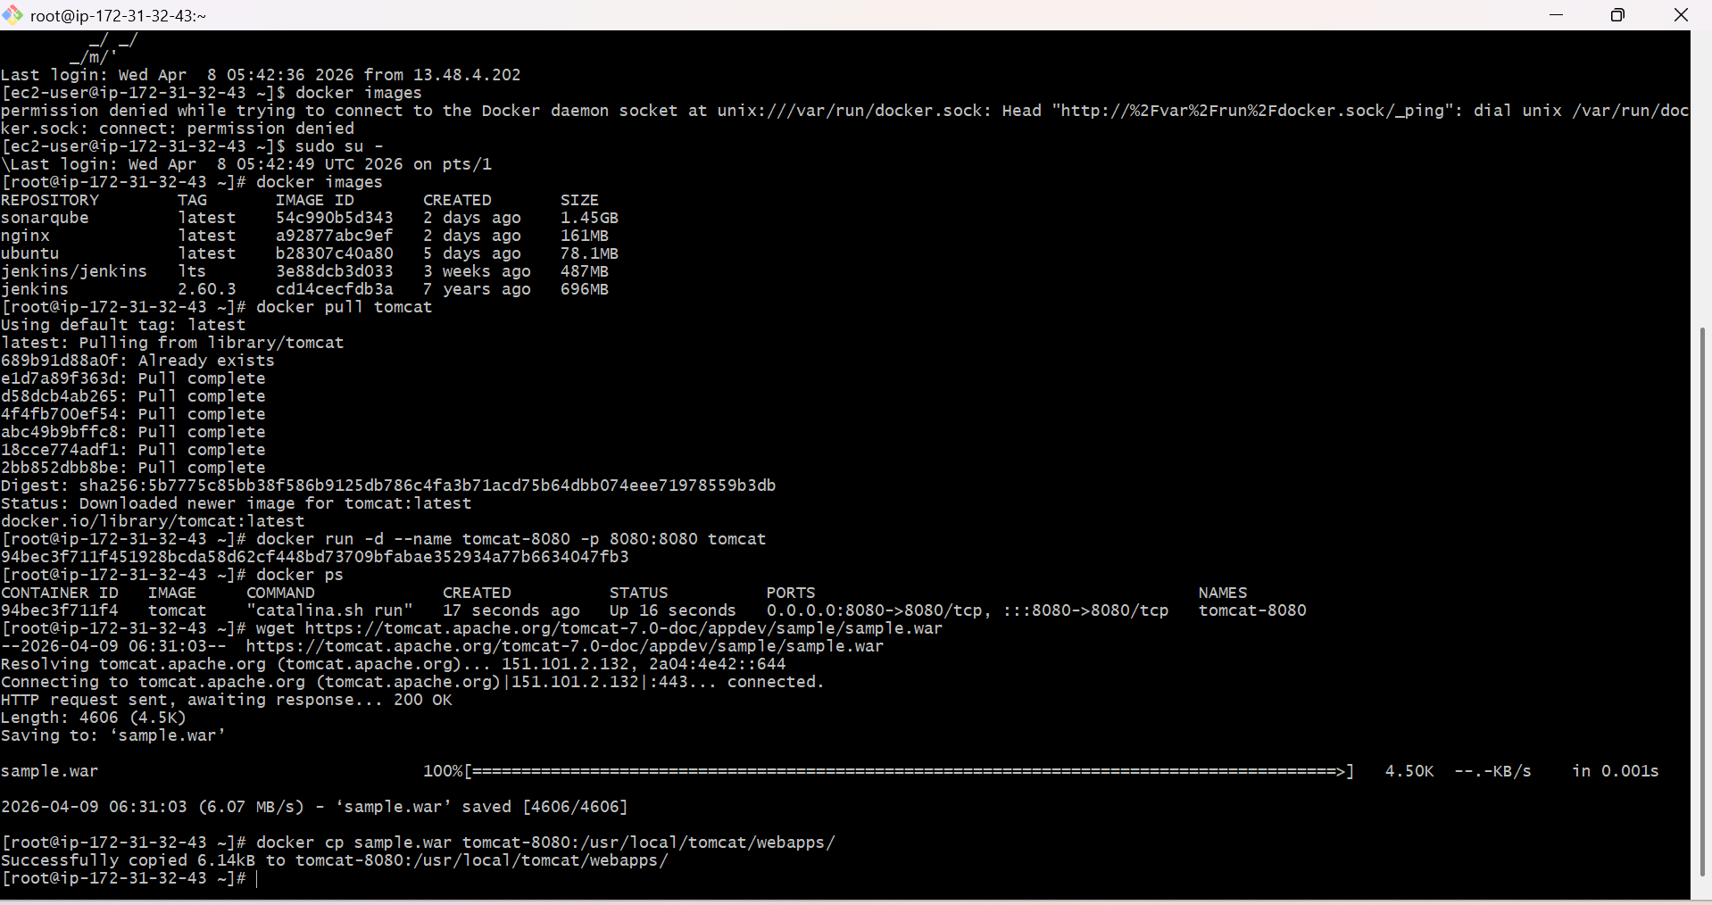
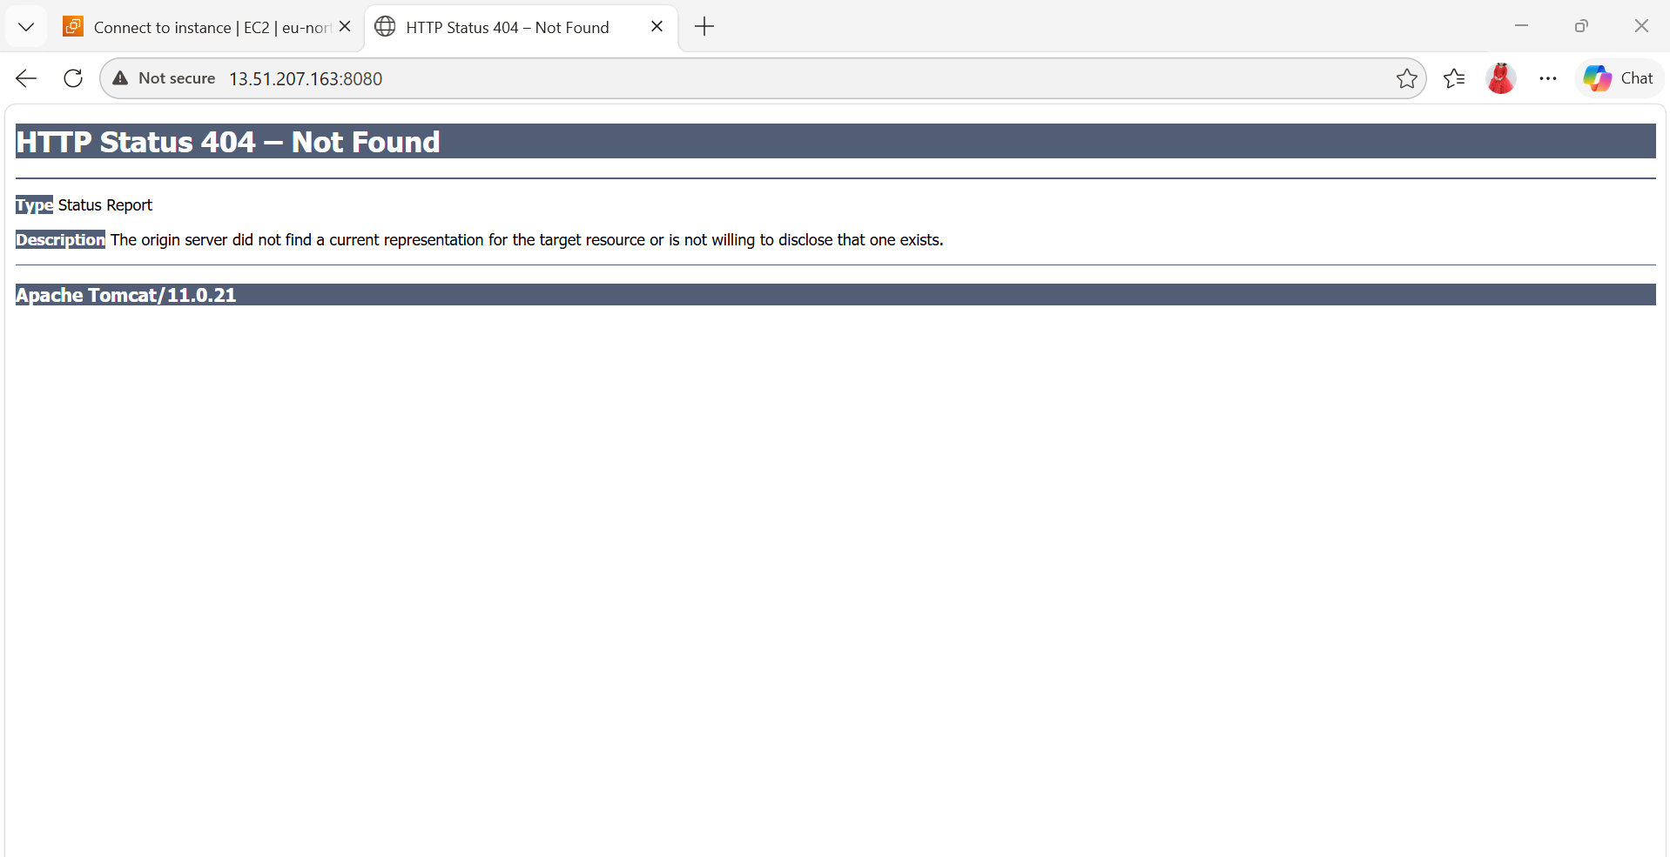

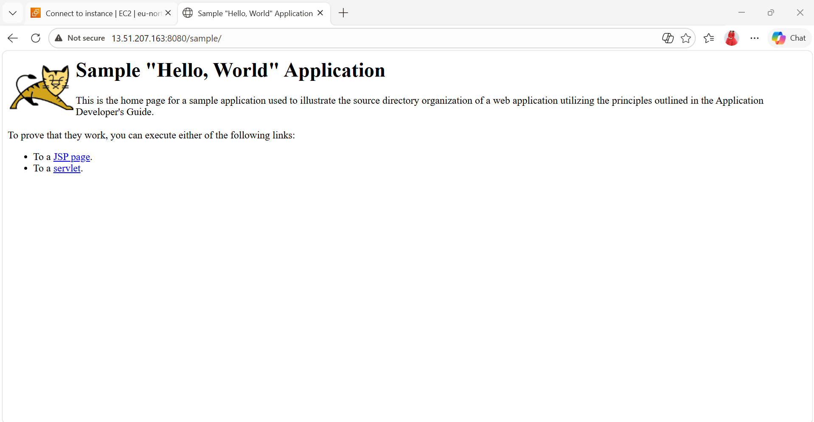
- Create volume and deploy tomcat container on port 8081.
  - Create a Docker Volume
docker volume create tomcat-data
  - Run Tomcat Container with Volume on Port 8081
docker run -d \
--name tomcat-8081 \
-p 8081:8080 \
-v tomcat-data:/usr/local/tomcat/webapps \
Tomcat
Explanation:
  - Check volume
  - docker volume ls
  - Copy sample WAR into second Tomcat
docker cp sample.war tomcat-8081:/usr/local/tomcat/webapps/
  - Access Application
Open browser: http:// 13.51.207.163:8081/sample
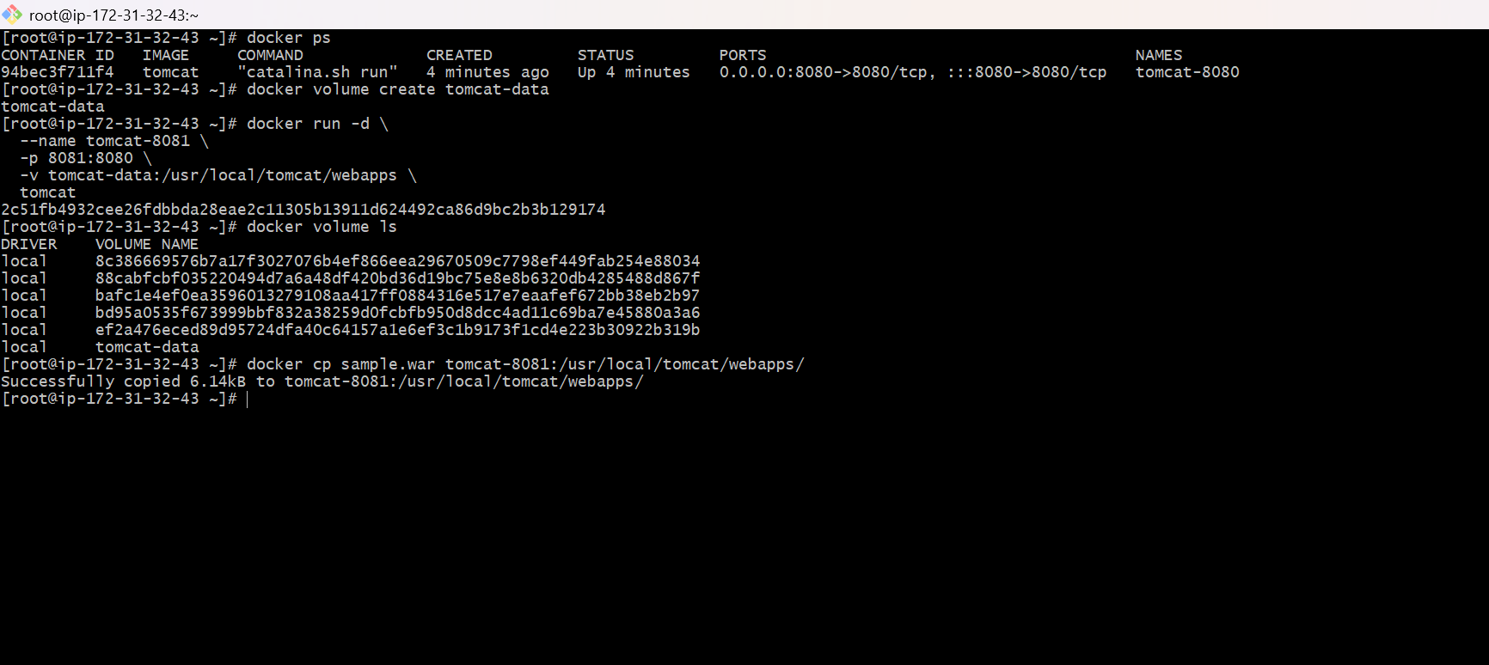
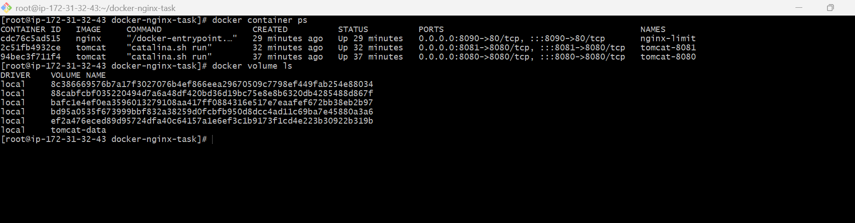
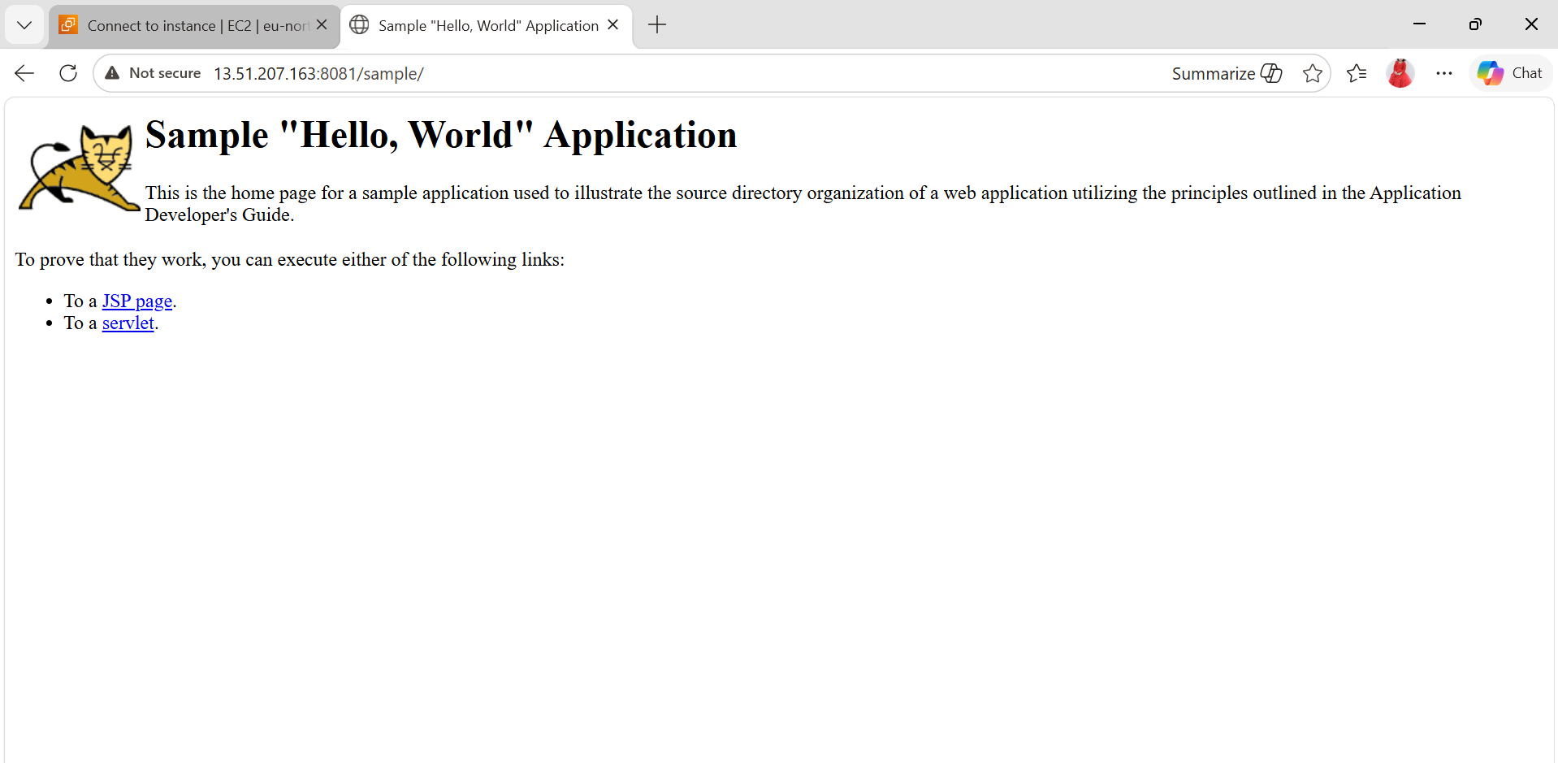

- Limit the nginx container to 500 MB.
  - Pull Nginx Image (if not already)
docker pull nginx
  - Run Nginx Container with Memory Limit
docker run -d -p 80:80 \
--name nginx-limited \
--memory="500m" \
nginx
  - Check the container size limit
docker stats
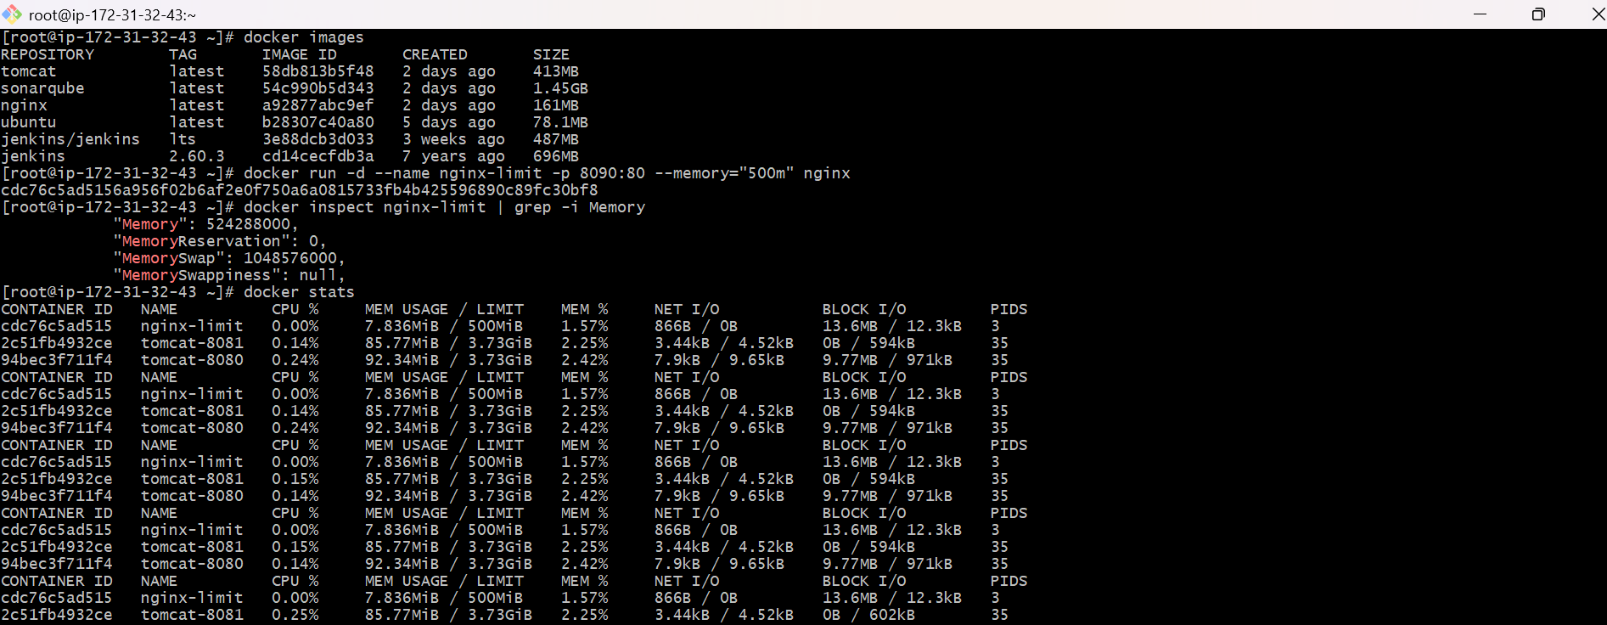
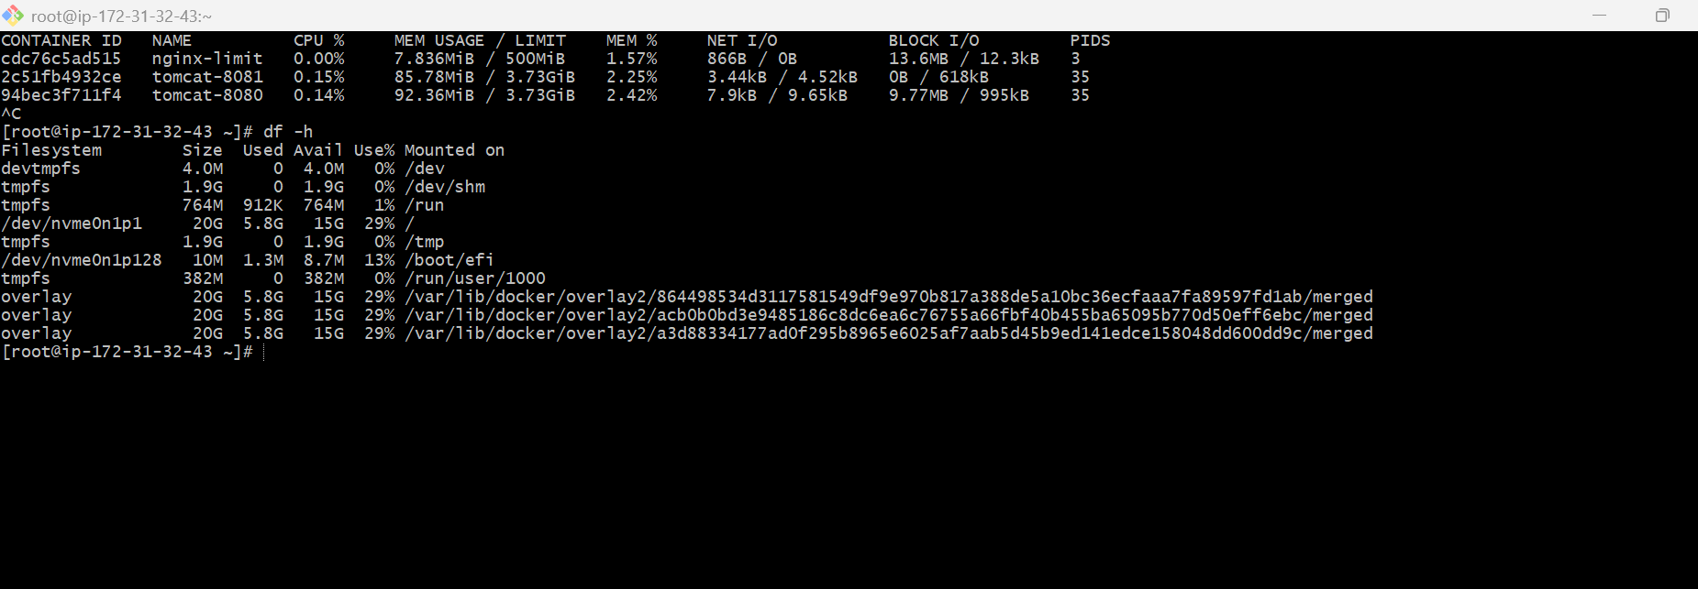

Create a sample docker file using below instructions.
- Base module as amazonlinux:latest
- Maintainer you name
- Install nginx
- COPY one index.html file to image
- Expose on port 80
Steps:
  - Create a folder
In your EC2 or Linux system:
mkdir nginx-docker-project
  - cd nginx-docker-project
  - Create index.html
  - Create Dockerfile
  - Build Docker Image
docker build -t my-nginx-app .
This creates your custom image
  - Run Container
docker run -d -p 8084:80 --name nginx-app my-nginx-app
  - Open in Browser
http:// 98.88.76.238:8084
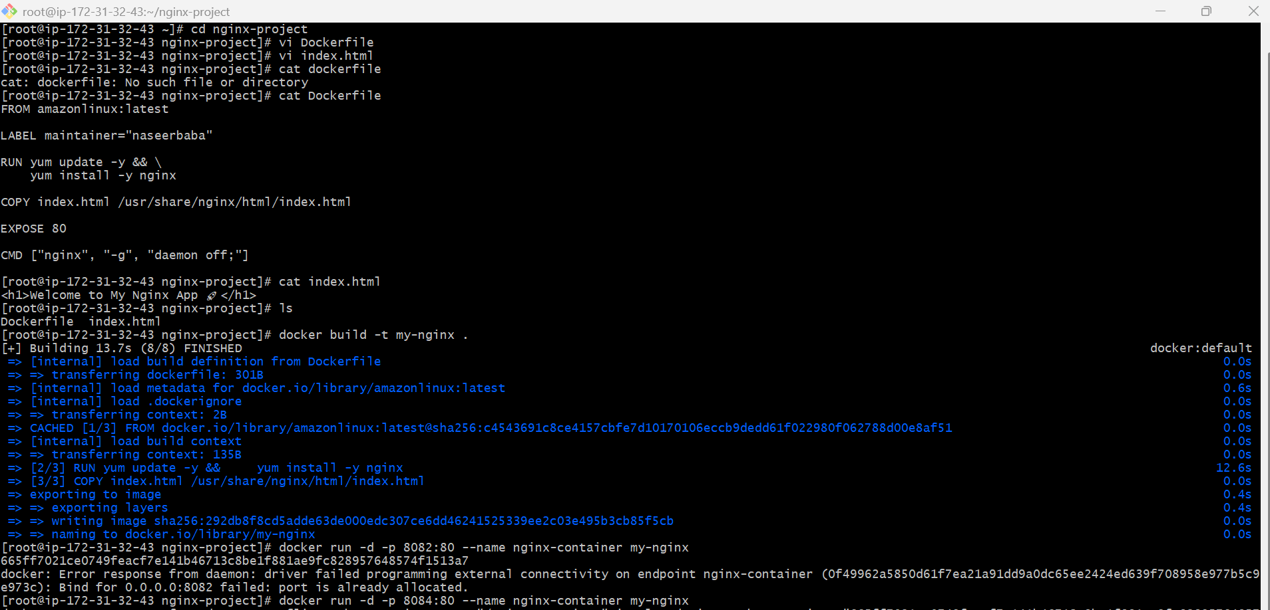

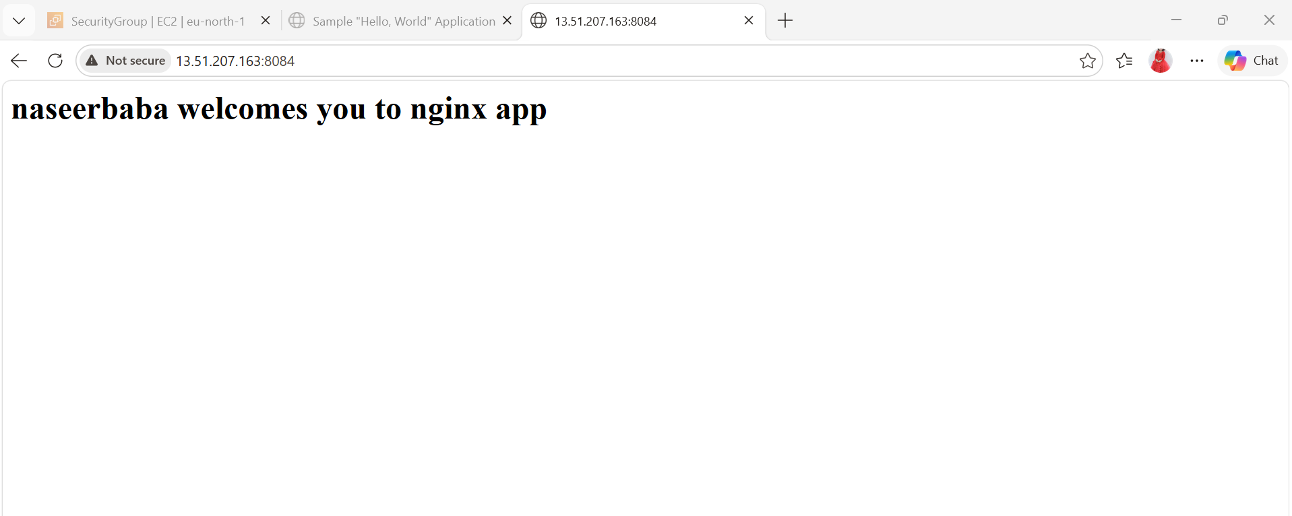

- Command to start the nginx container
Run Container
Docker start nginx-container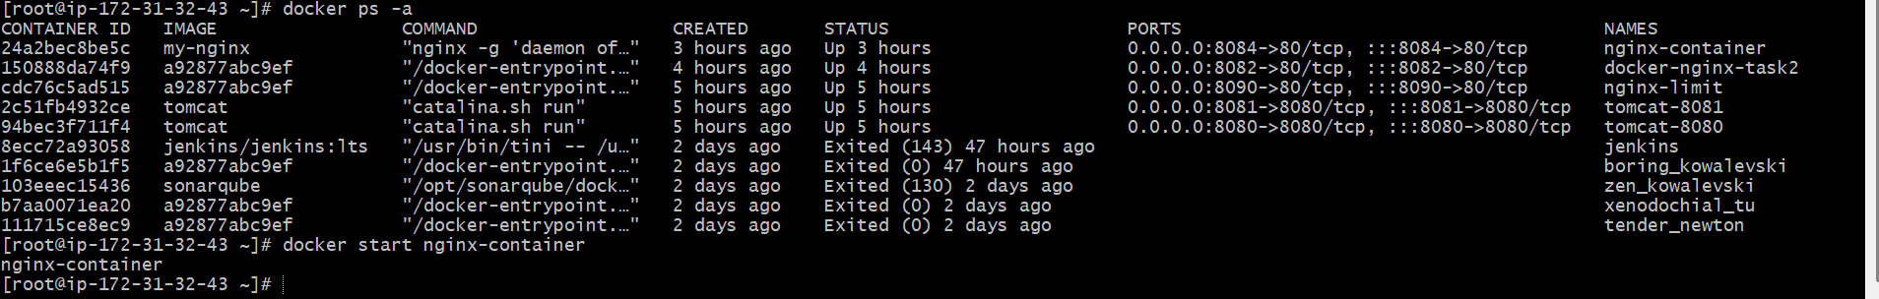

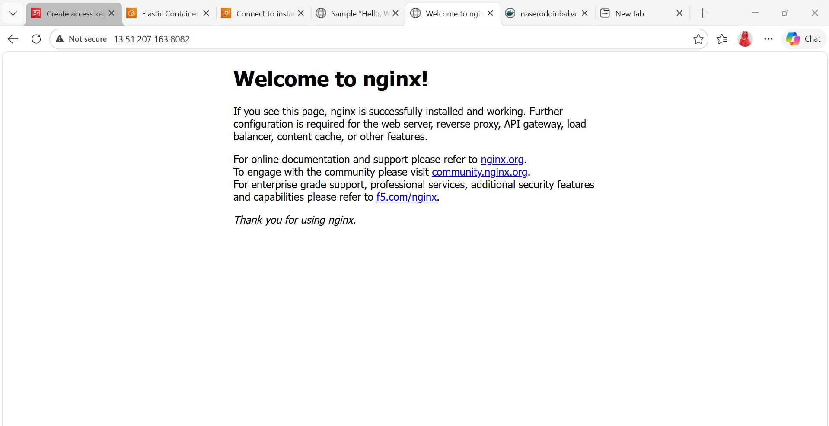

- Push image to Docker hub
  - Create Docker Hub Account
Go to:
Docker Hub (https://hub.docker.com)
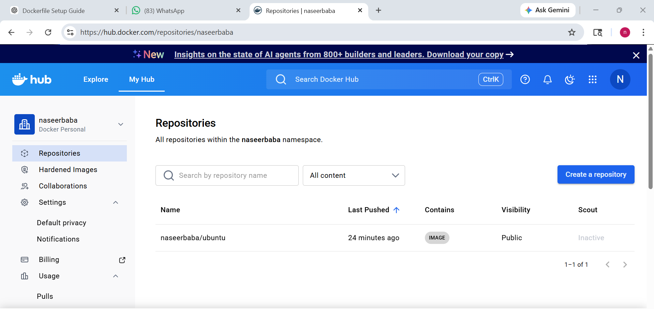
  - Login to Docker Hub
docker login
- Username: naseerbaba
- Password: your-password
  - Check your image
docker images
  - Tag the image
command:
docker tag ubuntu naseerbaba/ubuntu
  - Push the image
docker push naseerbaba/ubuntu
Output should show:
- Pushed
- digest
That means SUCCESS
  - Verify in Docker Hub
Go to Docker Hub
Login → Repositories → Check:
Naseerbaba/ubuntu
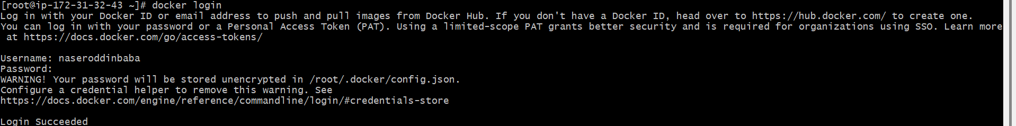
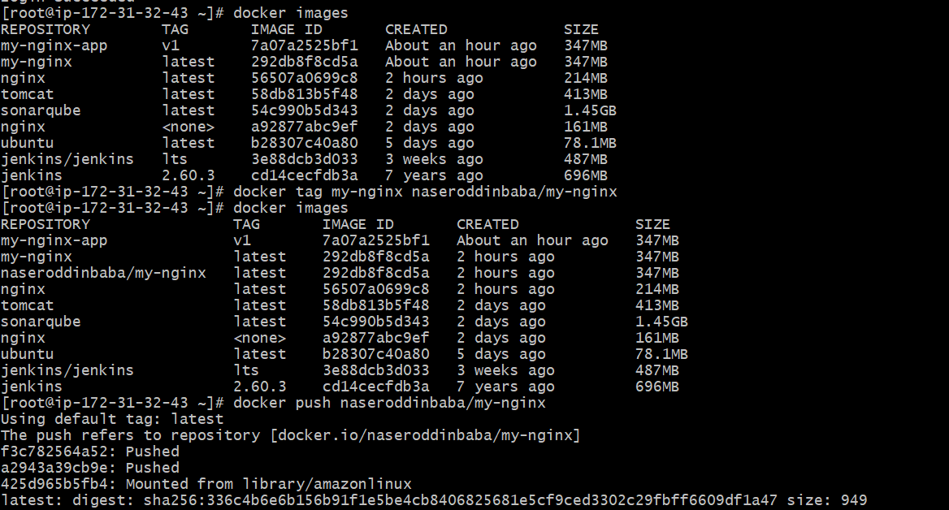
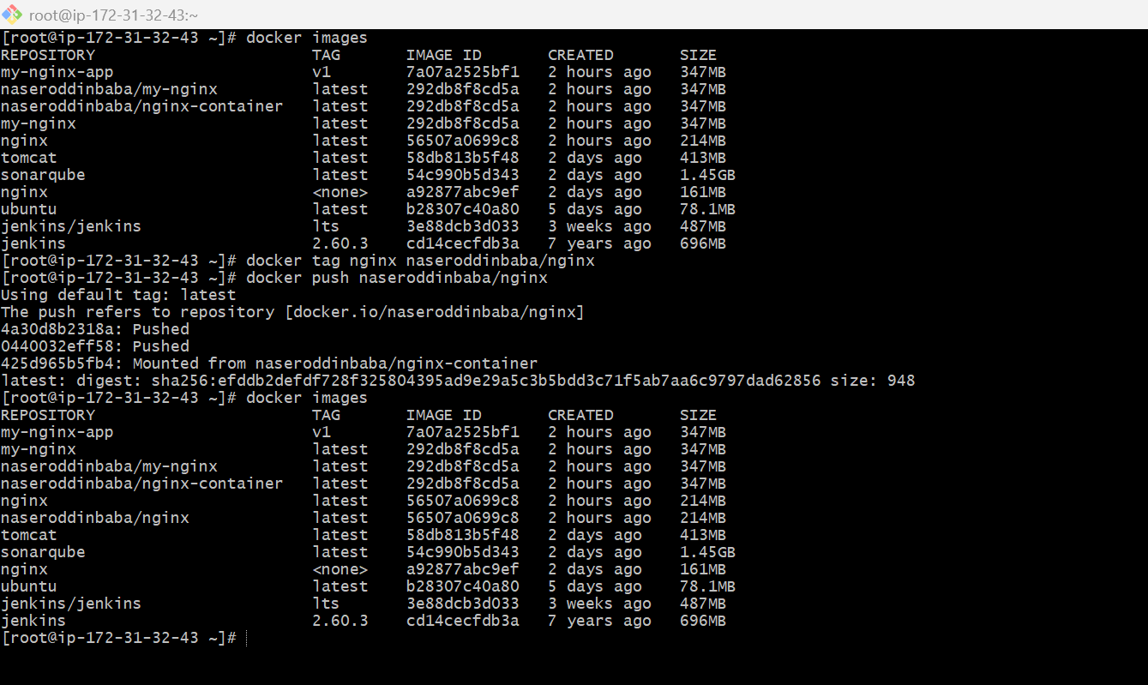
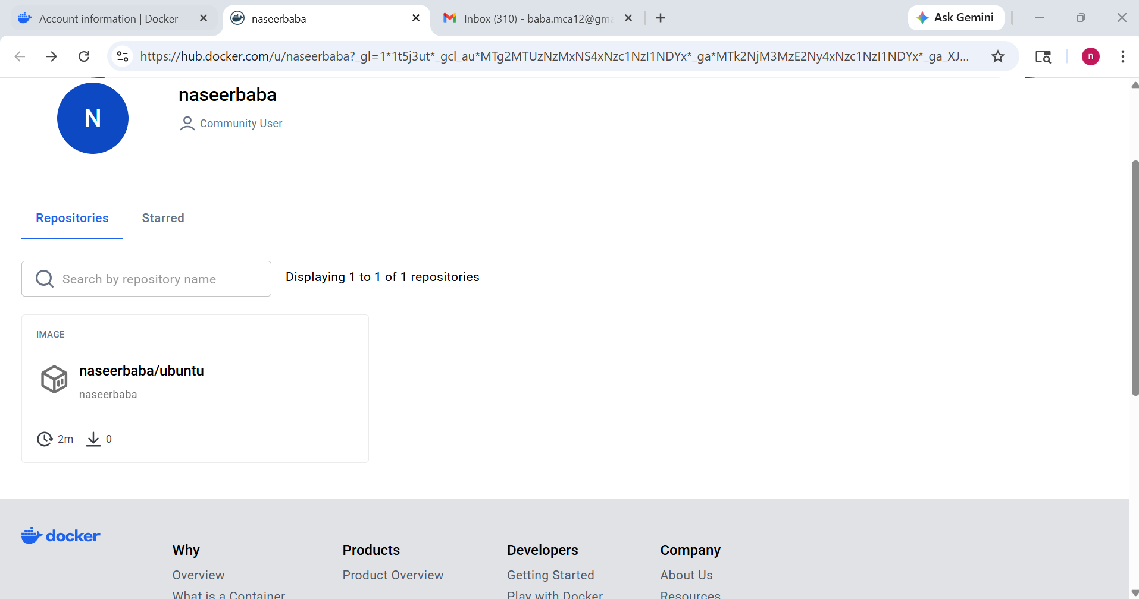

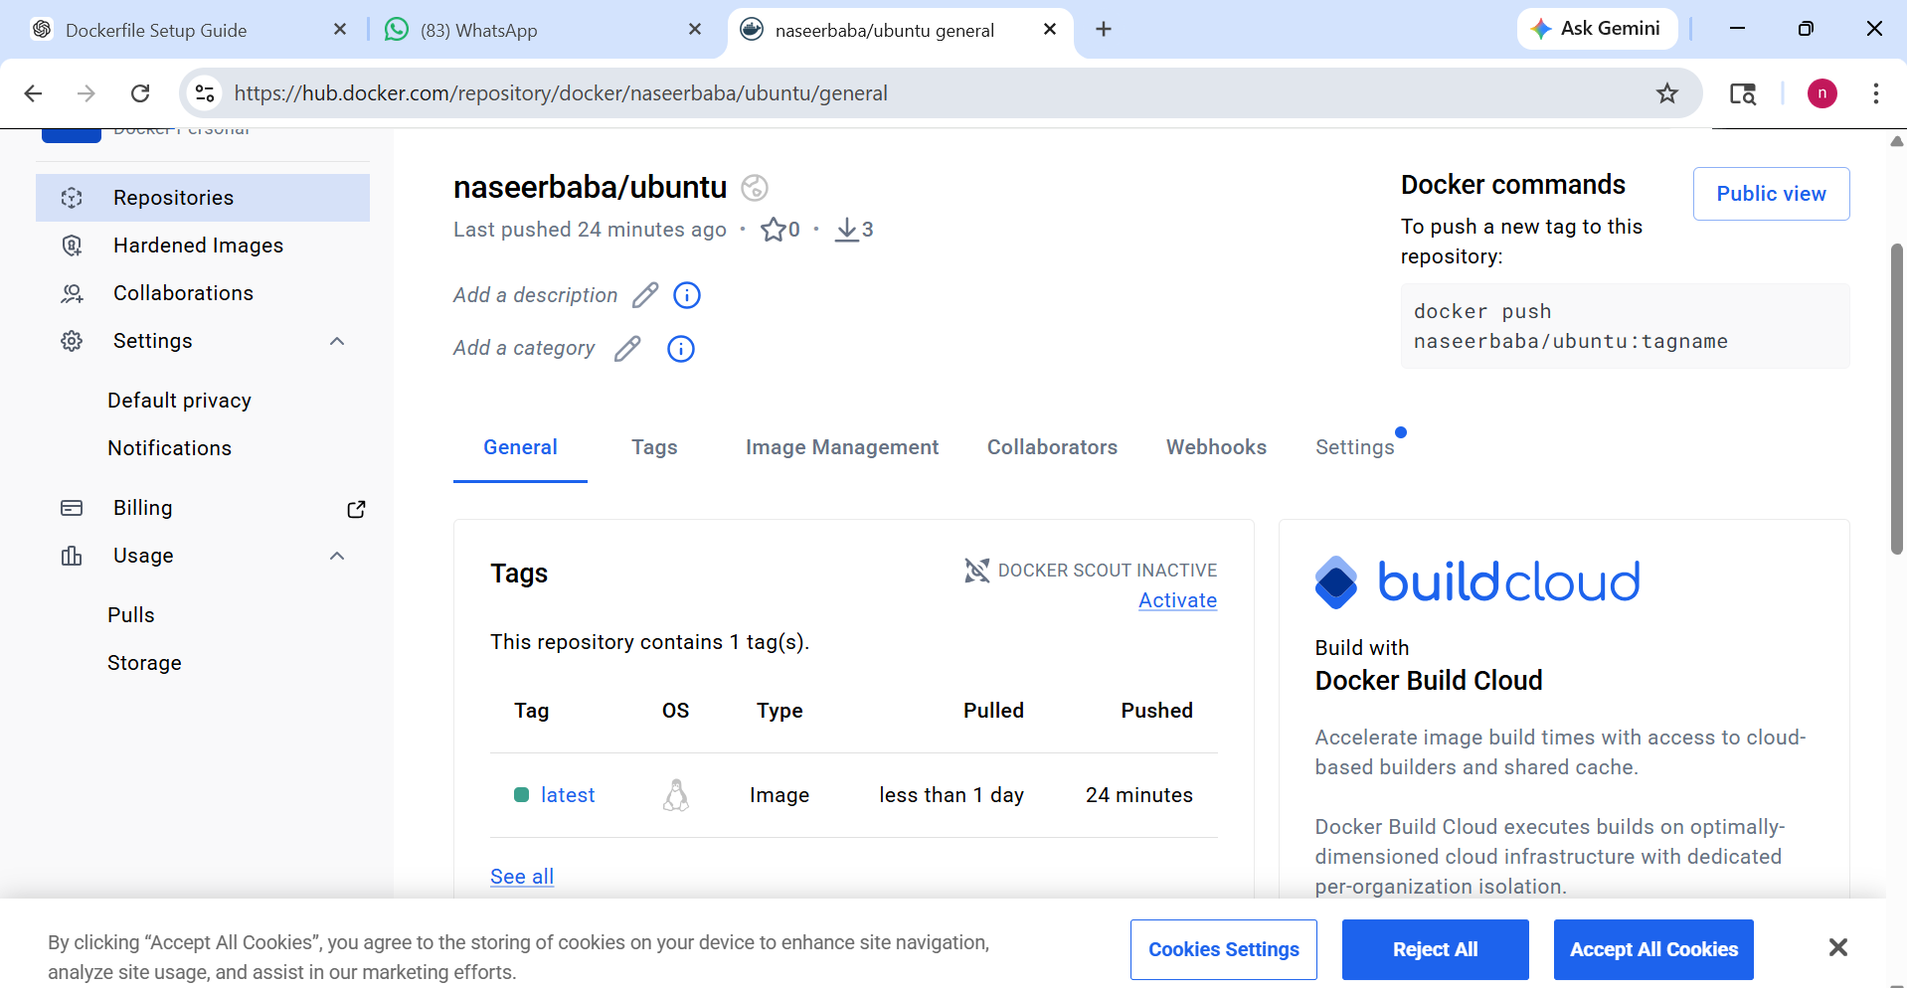
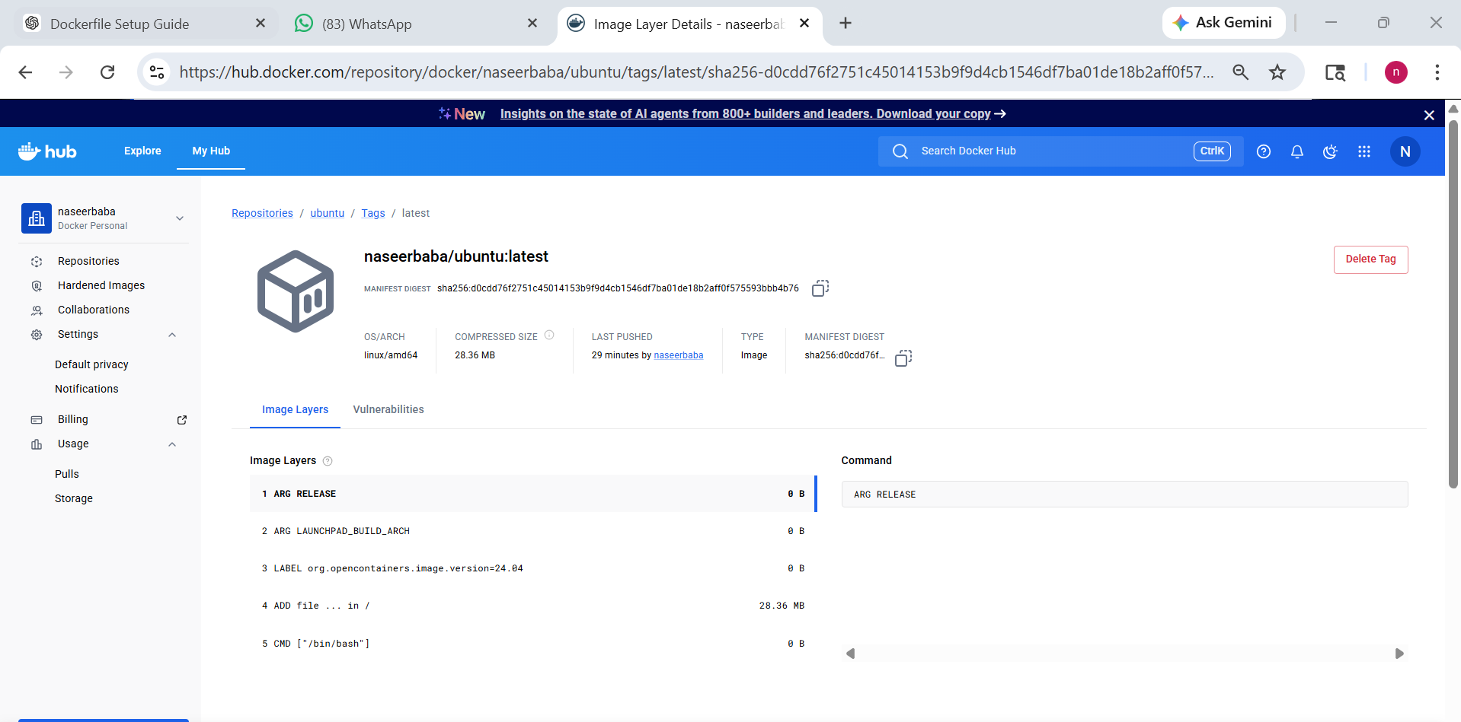
- push image to AWS ECR
  - Configure AWS
aws configure
Enter:
- AWS Access Key
- AWS Secret Key
- Region → eu-north-1
- Output → json
Step 2: Create ECR Repository
aws ecr create-repository --repository-name my-nginx --region eu-north-1
Output will contain:
repositoryUri: <account-id>.dkr.ecr.ap-south-1.amazonaws.com/my-nginx
Step 3: Login to AWS ECR
aws ecr get-login-password --region eu-north-1 | \
sudo docker login --username AWS --password-stdin 127521539590.dkr.ecr.eu-north-1.amazonaws.com
Expected:
Login Succeeded
  - Tag Your Image
Your local image:
my-nginx
Tag it for ECR:
docker tag my-nginx 127521539590.dkr.ecr.eu-north-1.amazonaws.com/my-nginx
  - Verify Tag
docker images
  - Push Image
sudo docker push 127521539590.dkr.ecr.eu-north-1.amazonaws.com/my-nginx
Output:
Pushing layers...
  - Verify in AWS
Go to: AWS Console → ECR → my-nginx
You’ll see your image there

